**SPRINT 1**

|  |  |
| --- | --- |
| Date | 29 October 2022 |
| Team ID | PNT2022TMID33811 |
| Project Name | Project – Smart Farmer-IoT Enabled smart Farming Application |

**CREATING ALL THE NEEDED ACCOUNTS AND INSTALLING THE REQUIRED SOFTWARES**

**GITHUB :**

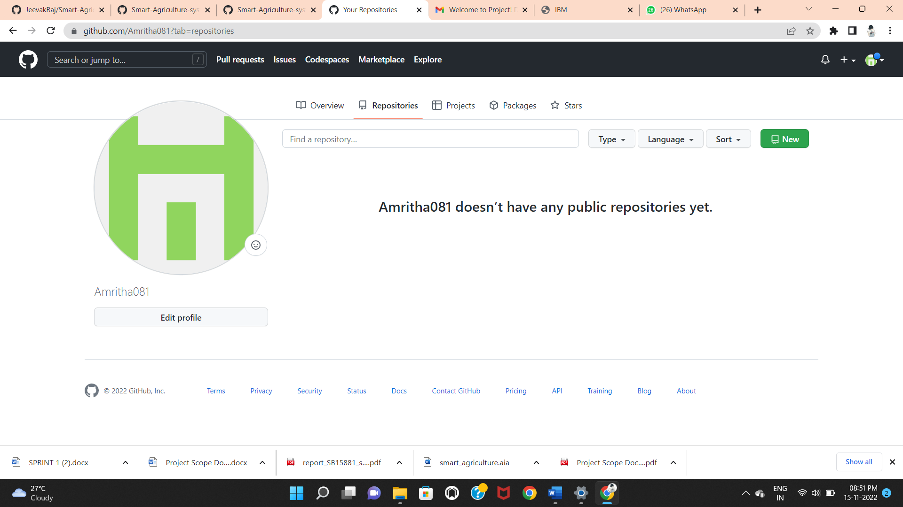

**NODERED:**

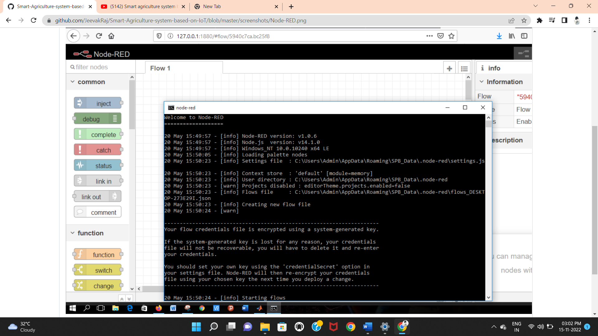

**FAST2SMS:**

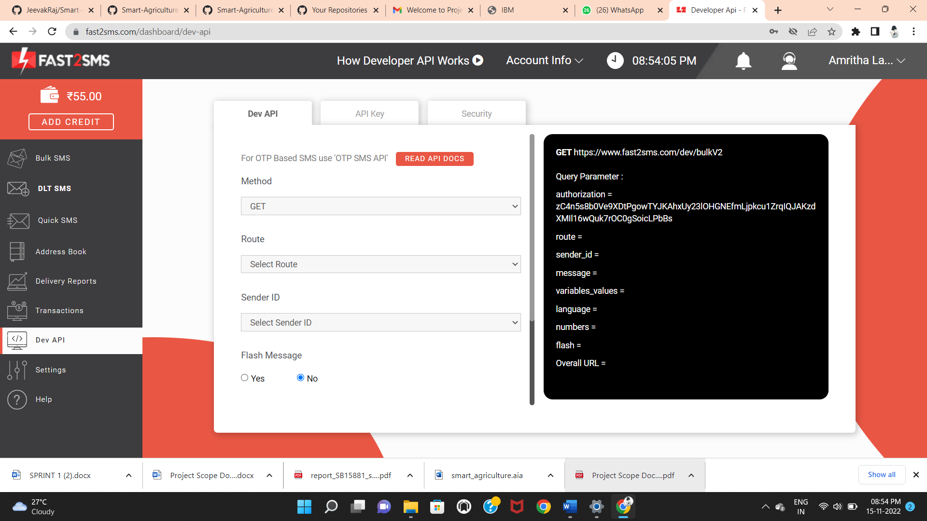

**IBM CLOUD:**

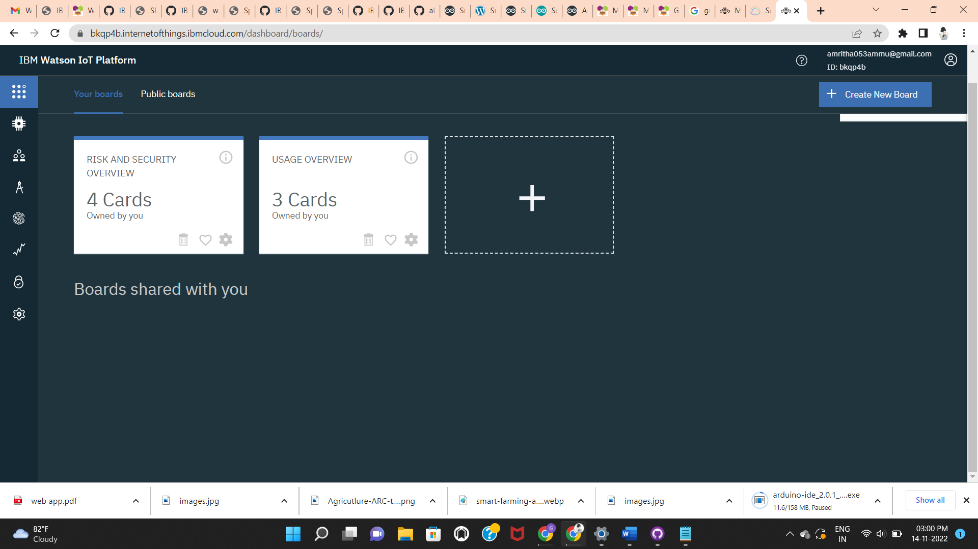

**MIT INVENTOR APP:**

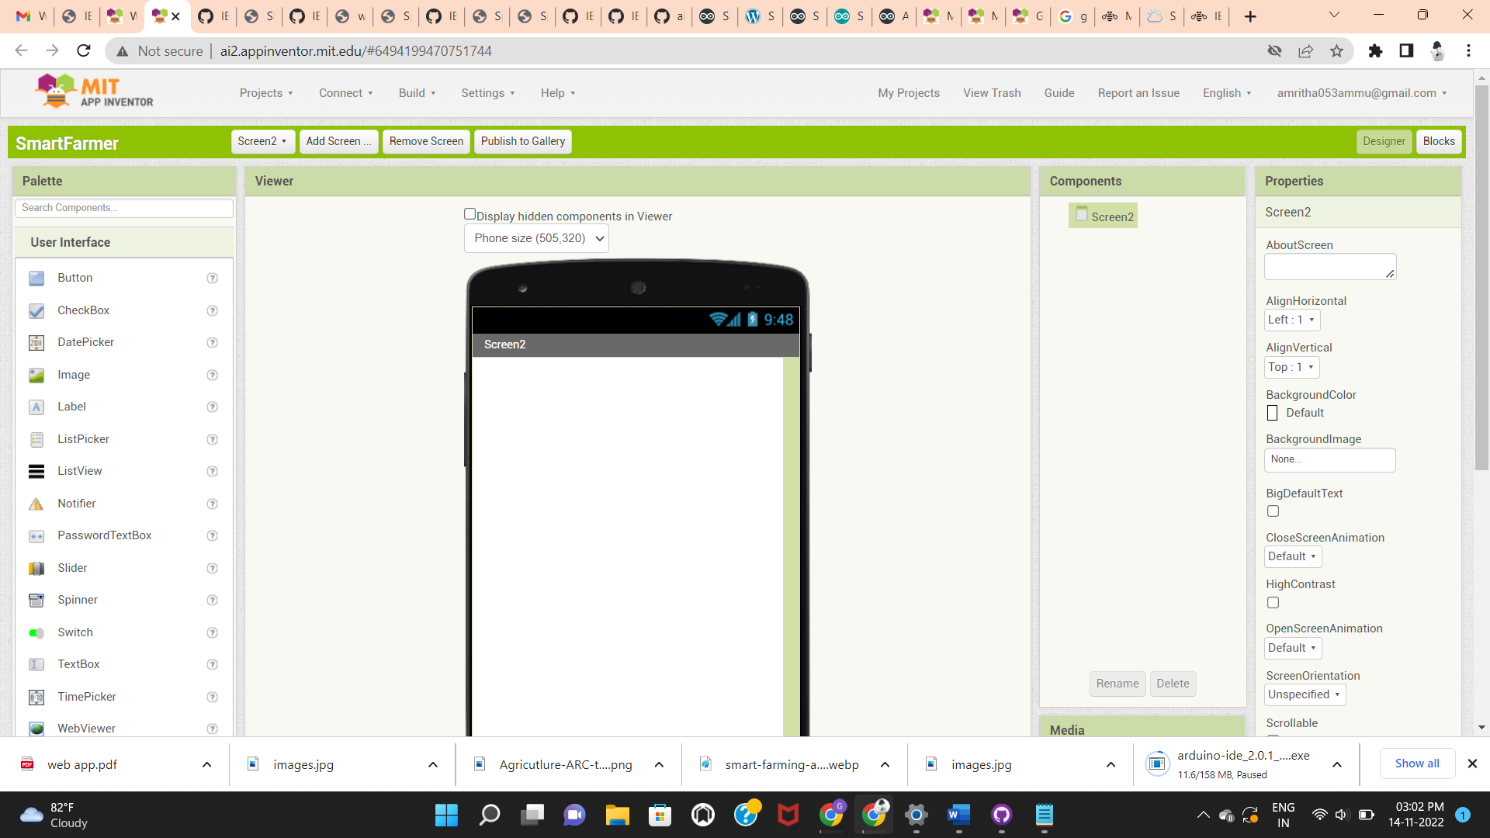

**PYTHON IDE :**

